Advanced Living Systems
Fish Dissection

Time: 25 minutes
Group Size: 10-15 students
Grade Levels: 6th – 8th grade
Location: At Sea

OVERVIEW OF ACTIVITY

Students will observe form and function of the external anatomy and with this information make a hypothesis on the habitat of a mackerel as well as their diet. Students will then dissect the mackerel to examine the digestive system linking all parts and test their hypothesis. The dissection will continue with the eye to observe the lens and its adaptation to a water environment. Continue with the respiratory system and any others as time permits. With a High School program, the dissection will continue, and they will hypothesize and observe any effects of bioaccumulation of pollution on this type of fish.

PERFORMANCE OBJECTIVES

Students will be able to:
- Identify the internal and external anatomy of the fish that are used in digestion, including the mouth, oral cavity, esophagus, pyloric caeca, stomach, intestines, and anus.
- Explain the relationship between fish digestion and the surrounding environment.
- Explain the effects of fish respiration on the surrounding environment (dissolved oxygen content)
High School:
- Given information on the diet and environmental conditions, students will be able to explain the relationship between digestion /respiration and pollution uptake. As well as, how contaminants are passed from one trophic level to the next and what may result.

CHALLENGE

Determine what habitat this fish lives in and what it eats. Determine what effect its habitat has on the Mackerel.

Additional Challenge MS/HS: Can any effects of bioaccumulation, caused by pollution, be seen within this fish.

MATERIALS

- (3-4) Thawed mackerel per instructor group
- Dissection equipment: pan, scissors, tweezers, and probe
- Fish dissection posters and sheets, including External Anatomy/Internal Anatomy of a Fish, Fish Adaptations and for HS group “Effects of Bioaccumulation Sheets”
- Magnifying lens
- Towels and other cleaning supplies

ADVANCE PREPARATION

- Take the fish out of the freezer to thaw.
- Hang the poster and/or put out sheets.
- Set the dissecting equipment on counter next to the sink.
- Set out cleaning supplies.

TEACHING TIPS
  - It is easy to go long on this station so watch your time. Don’t forget to leave time for station clean up. You must move off when the next group is ready.
  - The number of fish used for each group is related to the size of the fish and the group size. If you have very small fish, use one fish per three students. If you have large fish, use one fish per group of 8 or less around 1 table and use two fish for larger groups around 2 tables. The fish are kept in the Sahm “kitchen” upright freezer with the food for the animals. Make sure to let the lab director know if the box is getting low. Thaw the fish in cool water—never use hot water. When you clean up after your dissection, wrap the fish in newspaper, and put the bundle in the small trashcan. Rinse dissecting pans and tools between groups and clean completely after the program. Clean table and cards and reset for the next group.
  - Be a facilitator not a lecturer. Use a fish of your own to help point out organs to make sure they are all seeing the right thing. However, make sure it does not become the focus.
  - Staff and volunteers can use gloves if they want, but the gloves are not for the students.

PROCEDURE

Engage (2 minutes):
- Using your knowledge of structure and function, what observations are needed to be able to make a hypothesis about this fish’s habitat. (Tail shape, head shape and body structure)
- What is your hypothesis of its habitat and why?
- What information will we need to determine the Mackerel’s diet? How can we prove it? (We can dissect and look at stomach contents).
- Time permitting, we will continue with the eye and other systems.
- Middle School/High School: How would scientist determine whether or not this Mackerel has been affected by changes in its environment? (Examine internal organs)

Explore (6 minutes):
- External Anatomy: Developing a Hypothesis about Mackerel habitat and diet: Have the students observe the external anatomy of the fish.
- Using the External Anatomy and the Fish Adaptations diagrams students should describe body shape and coloration as well as note the location and function of the following structures: caudal fin, dorsal fin, pectoral fin, gill covering, lateral line, and mouth to determine where in the ocean the mackerel lives (open ocean, tidepools, deep sea? etc).
- Ask: what type of caudal fin the Mackerel has. (Forked)
- Ask: what body shape it has.
- Ask: based on coloration where might it live.
- Have the students develop a hypothesis about mackerel diet based on their observations of the mouth and jaw.
- Middle/High School: Take out the Marine Disease Cards. Have students observe the Gills and Scales. Note whether or not their fish is showing signs of disease.

Explain and Extend (2 minutes):
- Based on your observations, where do you think this fish lives?
- What observations did you make to determine its habitat? (Direct students to recall coloration and how it is uses countershading. Somewhere in
the pelagic)
- Based on your observations, what do you think this fish eats?
- What information did you use to determine this? (Ask students to recall the habitat of the Mackerel. Possibly other smaller fish.)
- What part of the food chain does that make this fish?
- How did you determine this? (Answers will vary depending on what they think it eats. The mackerel is a secondary consumer or predator.)
- Now that we have made our hypothesis, what procedure will you follow to test your hypothesis? (The procedure should include locating and dissecting the stomach to access and analyze the stomach contents.)

Middle/High School
- After observing the gills and scales what would you determine about the health of this Mackerel?
What signs led you to this analysis? (Discoloration of the scales; spots or discoloration of the gills)

Explore (8 minutes):
- Internal Anatomy: Proving the Hypothesis about Mackerel Diet: Have the students observe the internal anatomy of the fish. Lead the group through the dissection by giving oral instructions
- Dissection Procedures: Have the students put down all dissection tools and listen to your directions. Make sure to say they will all be participating in the dissection. Cut with the scissors starting at the anus and continuing between the pelvic fins to the narrow spot between the gills. Cut down from the anus down each side to help it open up. Have each interested student take part in the cutting—do not force anyone but encourage all to participate.
- Have the students use the Internal Anatomy Sheet to quickly note the internal anatomy. Students should identify and explain the function of the mouth, oral cavity, esophagus, stomach, pyloric caeca, intestines, and anus in the digestive process.
- Once they have visually identified these organs, have them verify the location of the stomach by carefully inserting the probe into the mouth of the fish and moving it slowly down the esophagus—they should see their probe moving through the digestive system and extending into the stomach.
- Have the students dissect the stomach and analyze the contents—usually the contents include scales but can contain krill or squid too.
- Continue with Eye dissection. Dissect the eye and take out the lens. Observe the shape of the lens.
- Middle/High School: Take out the Marine Disease Cards. Have Students make observations of the liver and heart. Note signs of disease.

Explain and Extend (2 minutes):
- Was your hypothesis confirmed by the data? (Answers will vary)

- How do you know? (Answers will vary but should reflect an understanding that the remnants contained in the stomach have a direct correlation to what the fish ate.)

- Did all of your fish eat the same thing? (Answers will vary but should reflect the stomach contents of the fish dissected. Stomach contents may include remnants of fish, squid, and shrimp.)

- What is digestion? (Digestion refers to the process by which food is broken down and absorbed into the body. In order to survive, animals need to eat, and they have an internal system (digestive system) that allows for the breakdown of food and the absorption of nutrients.)
- What internal organs is part of the fish digestive system? (The mouth, oral cavity, esophagus, pyloric caeca, stomach, intestines, and anus are all part of the digestive system.)
- What byproduct is produced during the digestive process? (Indigestible material and waste products are eliminated from the fish during the digestive process.)
- How does fish digestion affect the aquarium environment? (The waste products that are eliminated can affect water quality and the health of the fish living in a close system such as an aquarium.)
- Why is it important to understand the digestive process of a fish if you are an aquarist? (Aquarists need to know about this process to make sure that they monitor the abiotic components of the aquarium environment.)
- What shape is the lens? Is it the same shape as a human lens? (no) Why not? How does this relate to structure and function? Discuss refractive properties of light in water differ than air, to focus in water need round lens.

Explain and Extend (continued):
Middle/High School:
- How can pollution enter the marine food web?
- What is the source of ocean pollution?
- Can the stomach contents contribute to pollution uptake and dispersal with the specimen?
- Once in the system, how can contaminants enter and be stored within the fish.
- Discuss the nature of lipophilic (fat-loving) substances and their propensity to accumulate within certain organs.
- Explain bioaccumulation and biomagnification. (Use the biomagnification sheets to help students visualize these changes)
- Show how a scientist can identify toxicity levels by visual observations of the animal’s internal systems. Discoloration, growths or cysts, loss of color, and spots on organs are indicators of disease. Focus on the liver, kidney and gills. Is their color normal or discolored / white? Any cysts or lesions present? Is it an abnormal size? (Use the bioaccumulation sheets)
Middle/High School Extension: If you have time to do a gill dissection. Have the students cut out a gill arch and observe the filaments.
- What is respiration? (Respiration is the act of breathing in which oxygen is extracted from the air or water and transferred to the bloodstream.)
- How is respiration in a fish similar to and different from respiration in humans? (In order to live, fish must extract oxygen from the water and transfer it to their blood stream. In order to live, mammals must extract oxygen from the air and transfer it to their bloodstream.)
- What internal organs is part of a fish’s respiratory system? (Fish gills, heart, and blood are part of the respiratory system.)
- How does fish respiration affect the aquarium environment? (Fish need oxygen to survive. If there are too many fish (or other organisms) in an aquarium, the dissolved oxygen content can drop to a dangerously low level. Aquarists need to know what the demand for dissolved oxygen is in any aquarium and need to monitor to make sure that the demand is met.)
- Why does an aquarist need to know this? (Oxygen is essential for almost all life. Many fish can suffer when the dissolved oxygen drops below 3.5 ppm. Dissolved oxygen can drop to the danger or even lethal point in marine aquariums with high oxygen demands (dirty filters) and poor aeration. This means that fish respiration has an effect on the aquarium environment as well as the aquarium environment having an effect on fish respiration.)

Evaluate (2 minutes):

- What did you like about the fish dissection? Why? (Answers will vary depending on experience.)
- What did you dislike about the dissection? Why? (Answers will vary depending on experience.)
- What was the most difficult aspect of the dissection? (Answers will vary depending on experience.)
- How did you overcome the difficulty? (Answers will vary depending on experience.)

Clean Up (3 minutes)

RECOMMENDED ASSESSMENT STRATEGY
Observe the students as they discover the external and internal anatomy, providing feedback as necessary. Use the discussion questions and the number and type of questions asked and answered to assess student knowledge. Make sure those student responses to questions correspond to the answers provided.
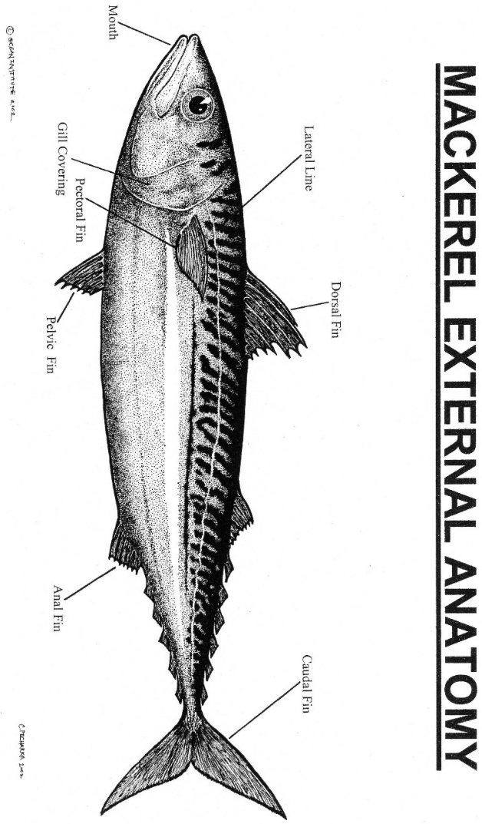
ACTIVITY RESOURCES
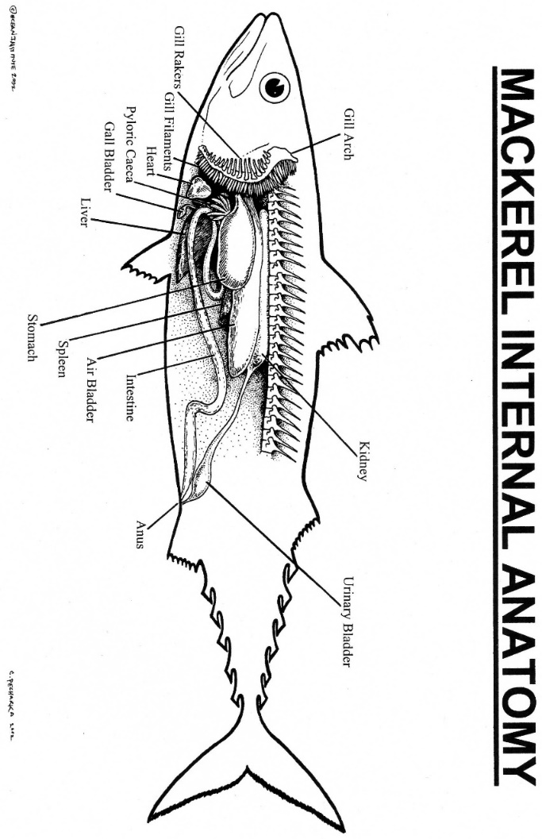

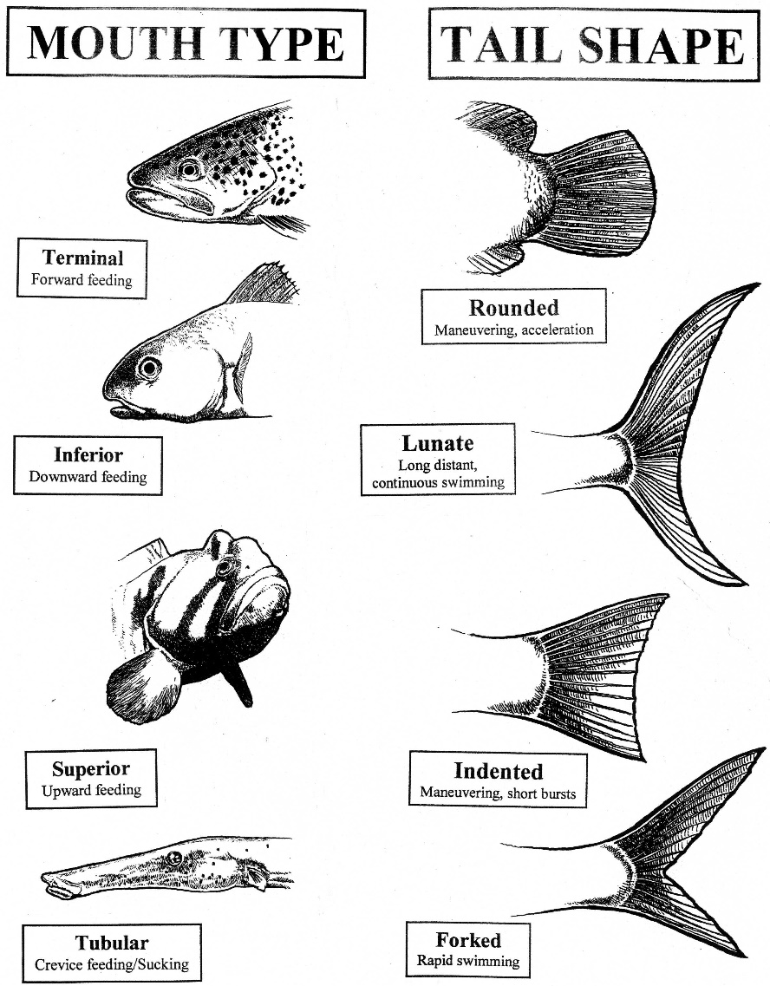

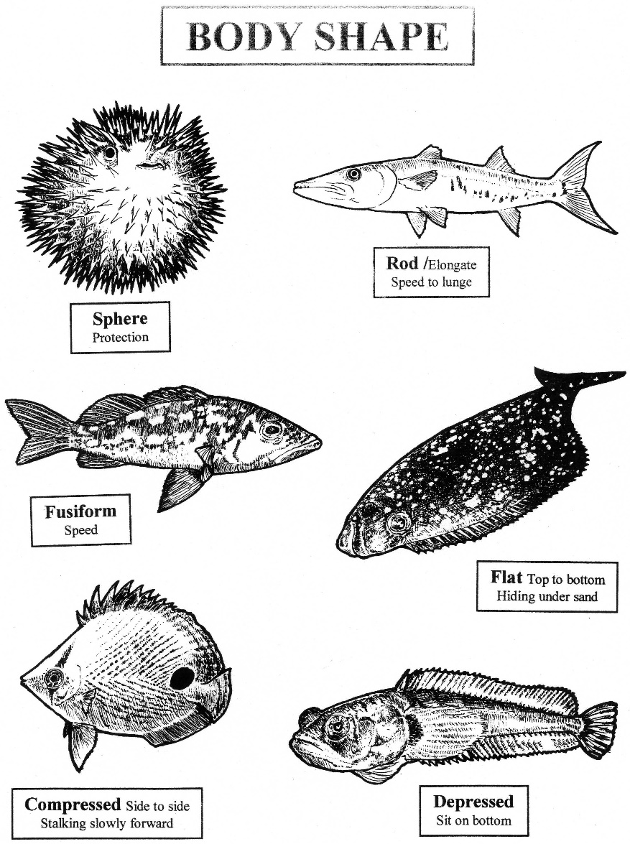

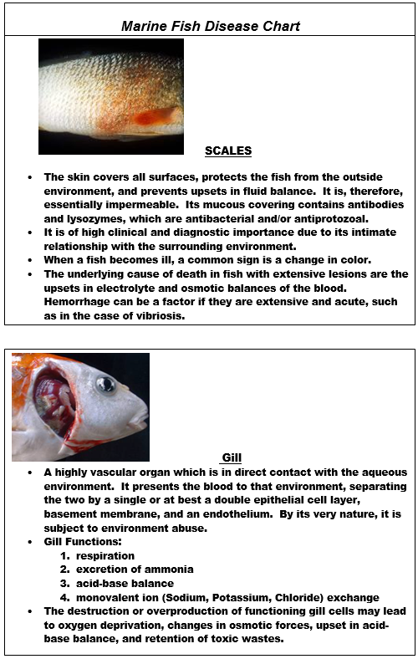

BACKGROUND INFO

The function of digestion is to dissolve foods by rendering them soluble so that they can be absorbed and utilized in the metabolic processes. The main organs that involve the food flow are discussed. Other glands and organs have digestive functions but are not discussed for example mucous glands, gastric glands, liver, gall bladder, and pancreas.

In a closed system such as an aquarium, fish digestion (biotic) can affect water quality (abiotic). The digestive process results in the elimination of waste in some form of ammonia. This affects the amount of ammonia contained in the water and can have ill effects on the fish.

Parts of the digestive system discussed at this station:
Jaw – variable in shape, size and location on the head depending on food and eating style.

Teeth – highly variable depending on diet and eating style. Teeth of some fish are not just on the jaw but also in the roof of the mouth, on the tongue, or in the pharyngeal cavity.

Esophagus – tube that connects mouth and stomach, in fish it is greatly distensible to get down large prey since they cannot chew food.

Stomach - holds and breaks down the food - shows adaptations in shape. In fish-eating fishes, the stomach is typically elongate.

Pyloric Caeca - digestive and absorptive functions: Attach at the stomach/ intestine area and look like finger-like projections.

Intestine - absorption takes place; length in different fish is an adaptation to food type, shortened in carnivores and elongated and folded in herbivorous species.

Anus – exit hole for waste.

External Anatomy:
Dorsal fin – used for balance.

Caudal fin – used for locomotion, note the shape from the diagrams and discuss purpose of this shape.

Pectoral fins– one pair, used for steering, brakes; note that it is relatively small for its size.

Pelvic fins– one pair, used for steering.

Anal fin - used for balance.

Mackerel also have finlets (most fish do not) – used to help minimize turbulence and therefore drag.

Gills – used for respiration gill arch, gill rakers, gill filaments.

Lateral Line – looks like dotted line along each side. The lateral line’s function is to sense pressure.
Eyes – there are no eyelids present, fish sleep with eyes open. They have a camera type eye with round lens. A round lens focuses light rays in water.

Scales – used for protection; note the use of countershading for camouflage.

Additional Information:
Heart - the heart is found in the head. The heart pumps blood to all parts of the body.

Air bladder – a thin membrane (much like a balloon) attached along the dorsal side. The air bladder is for buoyancy. Air goes in and out from the blood stream to make the fish buoyant at any depth. That is how a fish can hover in mid water and not sink. The air bladder helps to conserve energy.

Liver – storage and digestive functions: storage of fat, carbohydrates and fat-soluble vitamins (A, D); it produces bile that emulsifies fats and neutralizes pH in the intestines.

If the students ask how to tell males from females, (most fish cannot be sexed externally):
Gonads (testes or ovaries) - one pair of reproductive organs lay along each side at the anus extending about halfway up the abdominal cavity. In juvenile fish, the gonads are too small to tell the sex. Egg masses are in the ovaries and may contain thousands of eggs. The ovaries are yellowish in color and the testes are white.

Web site:
Here is a good web site that has photos of a blue mackerel dissection, which is very similar to our pacific mackerel. www.austmus.gov.au/fishes/students/dissect

